How To Run Email Bot with body from Clipboard

Step 1) Open Pycharm

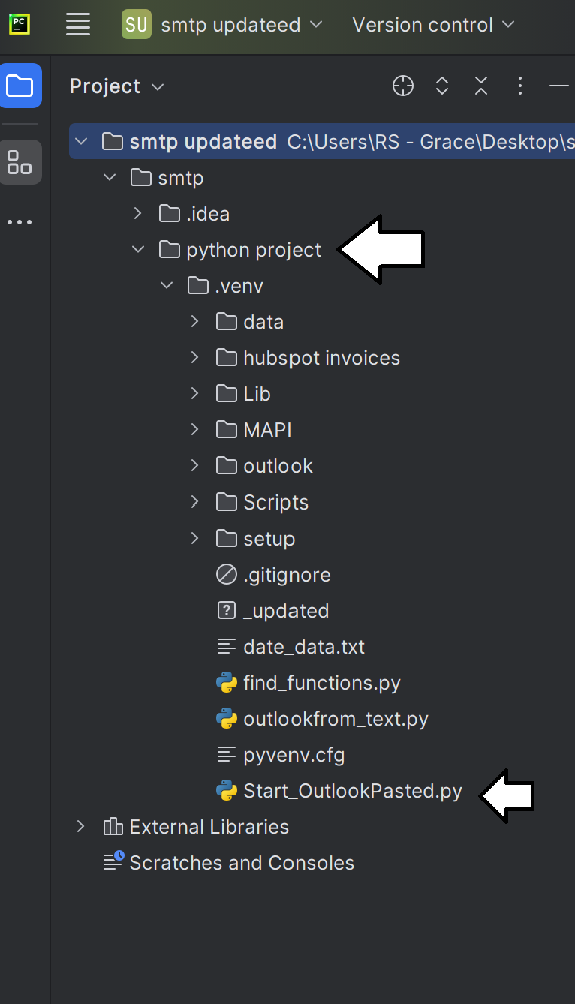

Step 2) click python project folder and then start_outlookpasted.py

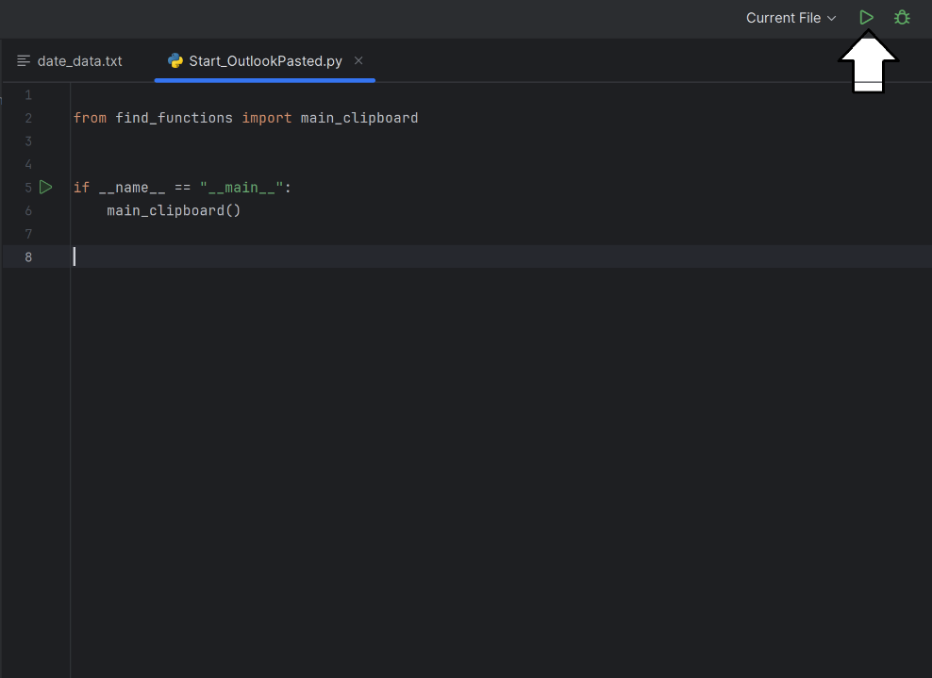

Step 3) click start button

Optional, if you want to edit the start date to today or draft more emails starting from the current hour.

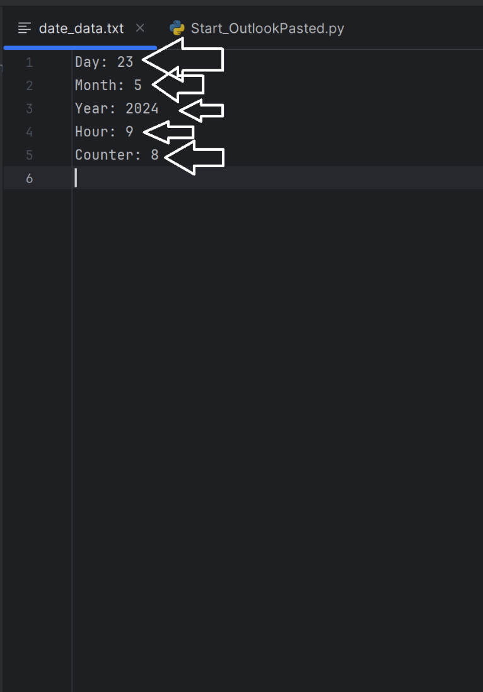

Precaution ensure 1 space between : and starting digit of date

Notes:

Day will always be updated to the current day if it has passed that day

Set desired start day

Set month to desired start month

Set desired year

If counter is not 0 and you changed the hour or day, set counter to 0.